**Documentation**

Target assessment level:

The target assessment level of this project is 3.

Specification:

**What does the program do?**

The program is a Library System allowing users to borrow and return books, view their borrowed books, and view all borrowed books in the system. The program takes multiple user inputs such as which task the user wants to achieve in the system (borrowing, returning, viewing, etc), usernames, and book names and organises it into lists (which is attached to each key inside the dictionary) and keys inside a dictionary that can be accessed by the user. The program is also capable of manipulating values inside the dictionary and lists such as adding or removing values and printing values at any given state.

**Input format**

The program takes 3 main types of user inputs.

Firstly, the user inputs an integer between 1 and 5 to tell the program what the user wants to do (it can be to borrow books, return books, viewing, etc). This is the main input that must be done always if the user is using the system.

The next two user inputs are optional but are required for some functions.

If the user wants to borrow and return books, the program will ask for the user’s username and book’s title. This is so that the program can use the username to store the books’ name under the username inside the dictionary.

If the user wants to view their currently borrowed books, then the program will ask for the username to access the data stored under it at that time.

If the user wants to view all borrowed books in the entire system, then the program will not ask for any additional information as it is not required.

Correctness:

**Typical test case**

Each function will be tested individually (after each test, the next one will be started in a fresh, new execution of the program and thus the program will not retain any previous information put into it from previous tests):

1. 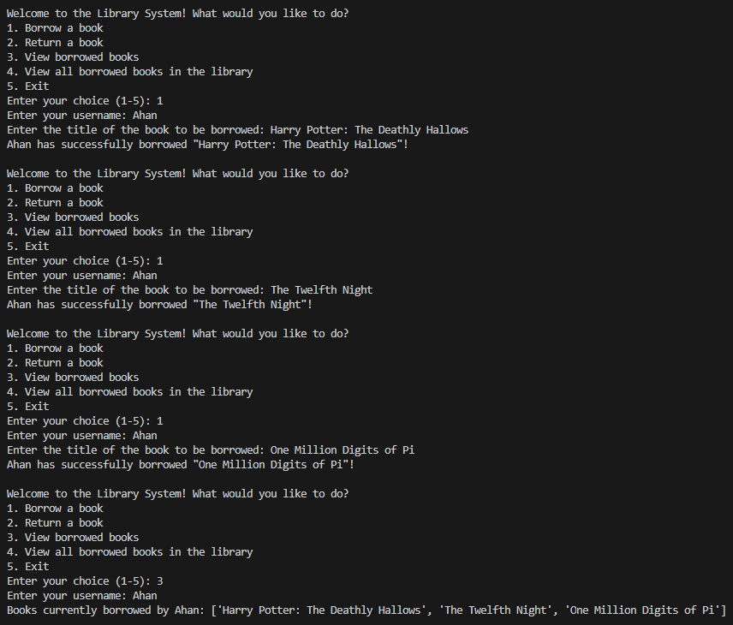Borrowing function:

As you can see, the borrowing works by adding the books to be borrowed into a list under the variable of “Ahan” inside the dictionary as a key-value pair (that is why when viewing all books under the variable “Ahan”, it printed the books that were previously under the username of “Ahan”). You can also add any other username, but it will add those books into another list under the other username.

1. A screenshot of a computer program

   Description automatically generated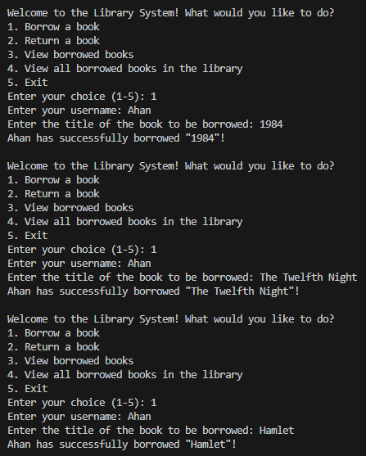Returning function:

As you can see, the returning function works by removing the books to be returned from the user’s list of borrowed books (that is why only 1984 is shows as borrowed although the user also borrowed “The Twelfth Night” and “Hamlet”).

1. 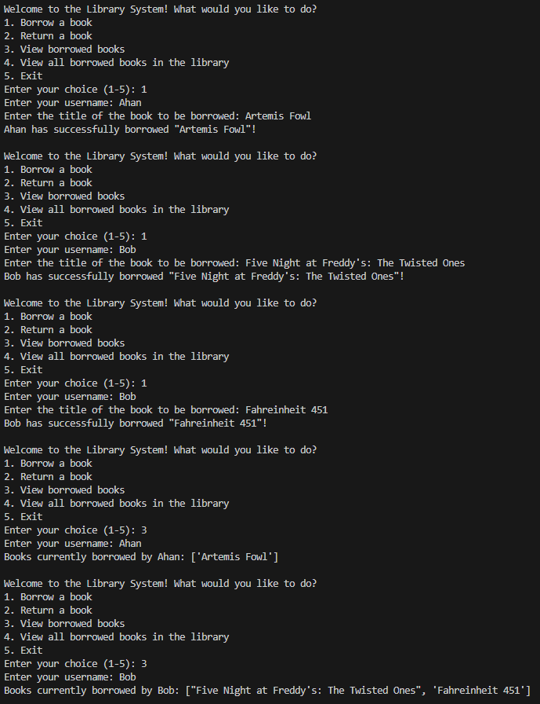Viewing user’s list of borrowed books function:

As you can see, the viewing each individual user’s list function works by printing each user’s lsit of borrowed books and it works for multiple users as well.

1. 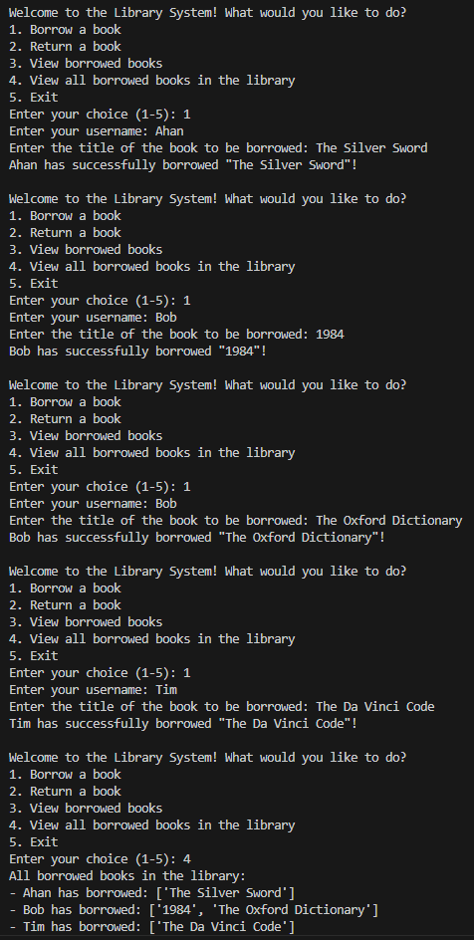Viewing the entire system function:

As you can see, the function thats prints all users and their lists of borrowed books does work correctly and it prints it for all users that are borrowing at that time.

**Resource handling:**

No files were used or opened in the program and thus no resource handling is necessary.